Pneumatic & Hydraulic Co.

Operations Manual



Mobile Refueling System

West Air Mobile H2 Refueler

Revision 6

Date Created: 5/27/2025

Table Of Contents

Warranty 2

Safety Statement 3

Introduction 4

Operations Process 5

Emergency Shutdown Procedure 17

Preventive Maintenance 18

Pneumatic & Hydraulic Schematic 18

Electrical Schematic 19

Appendix, A: Spare Parts List 22

Appendix, B: Additional Manuals: Kustec Cooling System "Racoon” 23

Main Components Kustec Cooling System "Racoon” 26

Maintenance & Maintenance Calendar: Kustec cooling system "Racoon” 27

Coldshot 20t Portable Air-Cooled Chiller (Model Acwc-240-E) Manual: 30

Coldshot 20T Chillier Maintenance: 35

Trouble shooting 20T Coldshot Chiller: 37

Appendix, C: Coldshot Chiller Start Up Checklist 40

**P&ID Valve Legend**

Within this manual you will see the following abbreviations representing components in this Hydrogen Mobile Refueler.

The abbreviations will be on the following pages: **6-11**, **15-16**.

|  |  |
| --- | --- |
| ABBREVIATION | DEFINITION |
| MIV | Manual Isolation Valve |
| MVV | Manual Vent Valve |
| DCIV | Digital Isolation Valve |
| DCVV | Digital Check Valve |
| TIV | Tank Isolation Valve |
| BIV | Ball Isolation Valve |
| HIV | Hot Isolation Valve |
| CWIV | Cold Water Isolation Valve |

# Warranty

Seller provides the following limited warranty for all equipment of Seller’s manufacture or assembly for a period of one (1) year from the date of shipment to Buyer: such equipment will materially meet the written specifications stated in the order and will be of good quality and workmanship for the equipment’s ordinary use. This warranty shall not apply to equipment or components not manufactured by Seller. With respect to equipment or components sold but not manufactured by Seller, the warranty obligations of Seller shall in all respects conform and be limited to any warranty actually extended to Seller by its supplier of such equipment or components, and Seller assigns said warranty to Buyer to the fullest extent allowed by law. For any services furnished by Seller (e.g., installation, maintenance), Seller warrants such services will be performed in general conformance with industry standards. All other warranties (for sales, services or otherwise) not expressly stated herein, whether express or implied (including but not limited to the warranty of fitness for specific use or purpose and/or redhibition or latent defects) are hereby waived. Seller’s warranty shall in no event apply to equipment or components which (i) shall have been repaired or altered by any person or entity other than Seller, or (ii) have been subjected to improper maintenance, operation or storage, other than normal usage or service, negligence or fault of any person or entity other than Seller, accident, or damage by any circumstances beyond Seller’s control. As the sole and exclusive remedy for any breach of warranty, at Seller’s sole option, Seller will either (i) repair or replace any non-conforming equipment or component(s) and/or re-perform any non-conforming services, or (ii) accept return of the non-conforming equipment or component(s) and return the purchase price or other compensation for applicable non-conforming services or goods to Buyer, in all cases without any other liability whatsoever, it being agreed that in no event will Buyer be liable for any costs or expenses for labor, transportation, removal, installation or other expenses in connection with the repair of replacement. In no event will Seller be responsible for any consequential, indirect, punitive, economic, or incidental damages which may be suffered by Buyer arising in any way out of the sale or services hereunder, regardless of whether occasioned by breach of warranty, negligence or other fault of Seller, its affiliates, suppliers, vendors, and/or subcontractors of any tier, and/or the employees of the foregoing. Notwithstanding any other provisions herein, in no event will Seller’s liability for warranty exceed 120% of Seller’s price or compensation for non-conforming equipment or services. Buyer releases, defends, and indemnifies Seller, its affiliates, distributors and vendors of any tier and their employees (“Seller Group”) for all liabilities, claims and causes of action for any, and all damages other than Buyer’s liability under the limited warranties hereof, REGARDLESS OF WHETHER CAUSED BY THE NEGLIGENCE, BREACH OF WARRANTY/DUTY, OR OTHER FAULT OF AND MEMBER OF SELLER GROUP. Buyer shall carry insurance of all types and amounts necessary to fully insure Buyer’s defense, indemnity and hold harmless obligations herein to the fullest extent allowed by law, but in no event less than $10 million of Comprehensive General Liability coverage, and all such insurance shall name Seller Group as additional insured, waive subrogation rights and be primary/non-contributary as respects Seller Group (all of such insurance is collectively referred to as “Seller’s Insurance”). Seller represents and guarantees that Seller has recovered all costs of Seller’s Insurance in the negotiated contract price for the sale and any services hereunder. CANCELLATION. Buyer may not terminate or cancel for convenience, or direct suspension of manufacture, except with Seller’s written consent signed by an officer of Seller and then only upon terms that will compensate Seller for the cost incurred as a result of any engineering, fabrication, purchasing, or any other cost relating to such termination, cancellation, or suspension, plus a reasonable amount for profit. ENTIRE AGREEMENT/MISC. These terms and conditions, and the matters set forth on the face of Seller’s offer to sell, constitute the entire agreement between Seller and Buyer. No prior or subsequent understandings, agreements or representations, express or implied, are part of this contract, nor shall any subsequent modification agreement or representation become part of this contract unless expressly agreed to in writing by an authorized representative of the Seller. In the event it becomes necessary for Seller to incur any costs or expenses in the collection of moneys due Seller from Buyer, or to enforce any of its rights or privileges hereunder, Buyer upon demand shall reimburse Seller for all such costs and expenses including but not limited to, reasonable attorney's fees, expert fees and costs of suit. Any typographical or clerical errors made by Seller in any quotation, acknowledgement or publication are subject to correction. This agreement shall be governed by the laws of the State of Louisiana, without giving effect to the choice of conflicts of law provisions thereof, and the parties expressly agree to exclusive jurisdiction and venue in the court of the Parish of Lafayette, Louisiana for any dispute arising hereunder.

Safety Statement

To ensure this quality product is safely and correctly utilized, all instructions within this manual must be read and understood prior to equipment start-up. Be aware of all the safety labels on machinery. If you do not understand any of the safety instructions contact your supervisor or product supplier immediately!

Compliance with safety standards, including federal, state and local codes or regulations is the responsibility of the purchaser(s). A safety study should be made of the products’ application by the purchaser(s). It is the purchaser’s responsibility to provide any additional guards, safety labels or other safety equipment deemed necessary based on this safety study.

The information contained in this safety manual is correct at the time of printing. Due to the continuing development of product lines, changes in specifications are inevitable. The company reserves the right to implement such changes without prior notice.

If you suspect fire hazards, safety hazards, dangers to health or any other job safety concerns, consult your federal, state or local codes.

Inspect equipment for safety labels. Make sure the personnel are aware of and follow safety instructions. Always maintain an orderly environment in the vicinity of Mobile Refueler. Clean up spilled materials or lubricants immediately. All personnel shall be instructed regarding the necessity for continuous care and attention to safety during the operation. They must be trained to identify and immediately report all unsafe conditions or practices relating to Mobile Refueler and its operation. Know your company’s machine specific Lockout / Tagout procedure. Do not perform maintenance until the electrical disconnect has been turned off! Replace all safety devices, guards and guarding prior to equipment start-up.

All electrical installations and wiring shall conform to federal, state and local codes.

Control stations should be so arranged and located that the operation of the affected equipment is visible from them. Control stations should be clearly marked or labeled to indicate the function controlled.

Remotely and automatically controlled products, and products where operator stations are not manned or are beyond voice or visual contact from drive areas, loading areas, transfer points and other potentially hazardous locations on Mobile Refueler path not guarded by location, position or guards shall be furnished with emergency stop buttons, pull cords, limit switches or similar emergency stop devices. The emergency stop devices shall be installed so that they cannot be overridden from other locations.

Only trained, qualified personnel shall be permitted to operate this machine. Training shall include instruction in operation under normal conditions and emergency situations.

It is the responsibility of the purchaser of this unit to train operating personnel in the proper manner of operation. It is furthermore understood that PHC Fluid Power assumes no responsibility for injury, disability, or death resulting from improper operation, removal, or bypassing of any electrical or mechanical safety devices incorporated in the design and manufacturing of this product.

The proper clothing for the job is always to be worn. Several types of protective equipment are available which can help you to avoid injury.

Introduction

At Pneumatic and Hydraulic Company LLC (PHC), we have been at the forefront of pneumatic, hydraulic, and fluid power technologies for over 60 years. Our extensive experience and unwavering commitment to quality enable us to provide innovative solutions and unmatched service to industries worldwide.

With a deep understanding of pneumatic and hydraulic systems, our team delivers cutting-edge, custom-engineered solutions tailored to meet the unique demands of each client. Whether you need hydraulic power units, pneumatic systems, or fluid handling solutions, we ensure that every project is executed with precision, efficiency, and reliability.

For six decades, we have built strong partnerships with our clients, offering not only high-quality products but also technical expertise and dedicated customer support. Our mission is to be your trusted partner in fluid power, driving your success with industry-leading products and comprehensive services.

**System Requirements:**

**HYDRAULIC OIL**

The performance of the hydraulic system depends on the quality of the hydraulic fluid used and should be selected according to the operating conditions. Refer to Haskel website for manufacturer oil and maintenance requirements. **Use the part number on the H-drive to confirm the proper manufacturer’s designed manual is found.**

The service life of hydraulic fluid is influenced by contaminants (particulate & water) and cracking caused by high temperatures.

* Contaminants should adhere to ISO 4406 19/17/14
* New hydraulic oil does not necessarily fulfil the required cleanliness requirement and should be filtered before adding to tank.
* Mixing diverse types/grades of oils should be avoided. This may lead to undesirable chemical reactions causing sludge.
* Tank temperature should be below 150°F.

The primary consideration when determining hydraulic oil is operating viscosity. Other choices must be considered such as fluid type, (synthetic, petroleum and water based) and other additives.

* Viscosity was selected based on ambient operating temperatures.
  + Temperature: 30F to 140°F ISO 32
  + 0°F to 70°F ISO 22

*Additional heaters may be added to tank for cold weather environments*

**ELECTRIC SERVICE**

Qualified and licensed personnel should commission electrical service according to local electrical codes. PHC Fluid Power should be consulted for electrical demands unique to each system. The following chart is provided as a reference only.

|  |  |  |  |
| --- | --- | --- | --- |
| **Product** | **Recommended Service (Amps)** | **Phases** | **Voltage** |
| **Mobile Refueler** | **550** | **3 Phase** | **480** |
| **H2 Compressor** | **250** |
| **T40 Chiller** | **150** |
| **T20 Chiller** | **80** |
| **Dispenser** | **40** |

**Table 1. Electrical Service Table**

**PRODUCT DIMENSIONS & WEIGHT**

|  |  |
| --- | --- |
| **Dimensions** | |
| **Length:** | **53ft** |
| **Width:** | **8ft** |
| **Height:** | **12ft** |

**Table. 2: Dimensions**

Operations Process

PHC Fluid Power equipment is carefully inspected and packed before leaving our factory. The transportation company assumes full responsibility for the safe delivery of this equipment. Visible damage or loss should be noted on the freight bill and signed by the person making delivery. A freight claim should be filed immediately with the transportation company. If damage is unnoticed or concealed until equipment is unpacked, notify the transportation company immediately and tell them you want to file a concealed damage claim. This must be done within three (3) days after delivery was made. Be sure to retain all package material and cartons.

WARNING: Installation of this equipment should be performed only by qualified personnel with consideration for local, state and federal regulations.

A qualified service technician should only perform adjustments and service work. Service & Installation is available through PHC Fluid Power.

**Pre-Setup**

**Electrical System:**

1. Install the Ground rod into ground.

2. Connect grounding rod to grounding cable.

3. Connect the Grounding cable to grounding lug mounted on trailer.

4. Visually inspect all wires to verify there is no visual damage to the external isolation coating.

5. Open the power distribution panel and ensure all the breakers are in the open/off position.

6. Hook up the 480V 60Hz 200kw power source to the main power distribution panel. Ensure the proper wire is used to handle the full load of the system. (consult local regulations to verify you meet code, PHC/THS is not liable for any issues related to supply power)

7. Do not move the breakers to the closed/on position until all pre startup check list is completed.

T40 Hydrogen Chiller:

* See manufactures manual for startup procedure, Racoon 45 US OD – MOD 1 set up

(**See Pages 23- through 29 of this document**)

20-Ton equipment Chiller set up (**See Pages 30- through 40 of this document**)

* See manufactures manual for startup procedure, for Cold Shot.

H2B700 – Hydrogen Booster 700 bar model

* Ensure all valves are in the following positions by manual means, below present in Compressor Skid area:

|  |  |  |  |
| --- | --- | --- | --- |
| Compressor Skid | | | |
| **Valve** | **Position** | **Valve** | **Position** |
| MIV1 | CLOSED | MVV3 | CLOSED |
| MIV2 | CLOSED | MVV4 | CLOSED |
| MIV3 | OPEN | CWIV1 | OPEN |
| MIV4 | OPEN | CWIV2 | OPEN |
| MIV5 | OPEN | CWIV3 | OPEN |
| MIV6 | OPEN | CWIV4 | OPEN |
| BIV1 | CLOSED | CWIV5 | OPEN |
| BIV2 | CLOSED | CWIV6 | OPEN |
| TIV1 | CLOSED | CWIV7 | OPEN |
| TIV2 | CLOSED | CWIV8 | OPEN |
| TIV3 | CLOSED | CWIV9 | OPEN |
| TIV4 | CLOSED | CWIV10 | OPEN |
| TIV5 | CLOSED | CWIV11 | OPEN |
| TIV6 | CLOSED | CWIV12 | OPEN |
| TIV7 | CLOSED | HIV1 | OPEN |
| TIV8 | CLOSED | HIV2 | OPEN |
| TIV9 | CLOSED | HIV3 | OPEN |
| MVV1 | CLOSED | HIV4 | OPEN |
| MVV2 | CLOSED | HIV5 | OPEN |

**Hydrogen Dispenser**

* Then, power on the system to open all DCIV valves while closing the DCVV valves, ensuring proper hydrogen flow with the MIVs remaining open.

|  |  |
| --- | --- |
| **Dispenser** | |
| **Valve** | **Position** |
| MIV-600-1 | OPEN |
| MIV-600-2 | OPEN |
| MIV-600-3 | OPEN |
| MIV-600-4 | OPEN |
| MVV-600-1 | CLOSED |
| MVV-600-2 | CLOSED |
| MVV-600-3 | CLOSED |
| MVV-600-4 | CLOSED |
| MVV-600-5 | CLOSED |
| MVV-600-6 | CLOSED |
| MVV-600-7 | CLOSED |
| DCIV-600-1 | CLOSED |
| DCIV-600-2 | CLOSED |
| DCIV-600-3 | CLOSED |
| DCIV-600-4 | CLOSED |
| DCIV-600-5 | CLOSED |
| DCIV-600-6 | CLOSED |
| DCIV-600-7 | CLOSED |
| DCIV-600-8 | CLOSED |
| DCVV-600-1 | CLOSED |

**Nitrogen Purge**:

**Note: this must be completed prior to and every time after introducing hydrogen for the first time and every time air has or potentially entered the system.**

* Deactivate power
* Connect Nitrogen supply line to Nitrogen inlet bulkhead on the H2B700 Hydrogen Booster.
* In the main power distribution panel move the main power breaker to the closed/on position.
* In the main power distribution panel move the breaker for the Compressor to the closed/on position.
* In the main power distribution panel move the breaker for the dispenser to the closed/on position.
* Ensure all Valves are in the following positions listed below: The DCIV Valves will be operated from the HMI (Human Machine Interface) on the H2B700.

|  |  |  |  |
| --- | --- | --- | --- |
| **Compressor Skid** | | | |
| **Valve** | **Position** | **Valve** | **Position** |
| MIV1 | CLOSED | MVV3 | CLOSED |
| MIV2 | OPEN | MVV4 | CLOSED |
| MIV3 | OPEN | DCIV1 | OPEN |
| MIV4 | OPEN | DCIV2 | CLOSED |
| MIV5 | OPEN | DCIV3 | OPEN |
| MIV6 | OPEN | DCIV4 | CLOSED |
| BIV1 | OPEN | DCIV5 | OPEN |
| BIV2 | OPEN | DCIV6 | OPEN |
| TIV1 | OPEN | DCIV7 | OPEN |
| TIV2 | OPEN | DCIV8 | OPEN |
| TIV3 | OPEN |  | |
| TIV4 | OPEN |
| TIV5 | OPEN |
| TIV6 | OPEN |
| TIV7 | OPEN |
| TIV8 | OPEN |
| TIV9 | OPEN |
| MVV1 | CLOSED |
| MVV2 | CLOSED |

**Nitrogen Purge continued:**

|  |  |
| --- | --- |
| **Dispenser Valving** | |
| **Valve** | **Position** |
| MIV-600-1 | **OPEN** |
| MIV-600-2 | **OPEN** |
| MIV-600-3 | **OPEN** |
| MIV-600-4 | **OPEN** |
| MVV-600-1 | **CLOSED** |
| MVV-600-2 | **CLOSED** |
| MVV-600-3 | **CLOSED** |
| MVV-600-4 | **CLOSED** |
| MVV-600-5 | **CLOSED** |
| MVV-600-6 | **CLOSED** |
| MVV-600-7 | **OPEN** |
| DCIV-600-1 | **OPEN** |
| DCIV-600-2 | **OPEN** |
| DCIV-600-3 | **CLOSED** |
| DCIV-600-4 | **OPEN** |
| DCIV-600-7 | **OPEN** |
| DCIV-600-8 | **OPEN** |
| DCVV-600-1 | **CLOSED** |

* Slowly introduce nitrogen gas into the system up to a pressure slightly above atmospheric (5-10 psi) to displace any remaining gases.
* Allow nitrogen to flow through each component of the system, including tanks, compressor, and any associated piping.
* Gradually increase pressure to the working purge of 500 psi.

**Purge Using Cycles of Pressurization and Venting:**

**Safety Considerations:**

Always perform purging in a well-ventilated area to prevent nitrogen buildup and oxygen displacement in the workspace. Maintain continuous monitoring for hydrogen leaks once introduced into the system. Follow all applicable codes, standards, and local regulations for handling and purging hydrogen systems.

* **Pressurized:** Pressurize the system with nitrogen to the designated purge pressure
* **Hold:** Allow nitrogen to remain in the system for several minutes, allowing thorough mixing and displacement of residual gases.
* **Vent:** Slowly vent nitrogen through **MVV-600-5, MVV-600-6, AND MVV-600-7** in the dispenser while monitoring for complete gas displacement. (Refer to dispenser manual for additional steps)
* Repeat the pressurize-hold-vent cycle at least three times or until the desired purity level is confirmed, with no residual oxygen or contaminants.

**Monitor Purge Effectiveness:**

* + Use a gas analyzer at the vent to confirm low oxygen levels (typically below 1%) and absence of other impurities.
  + Continue the purge cycle until readings indicate that only nitrogen is present, ensuring complete purging of all oxygen and contaminants.

**Final Nitrogen Purge Verification:**

* + Once purging is complete, conduct a final nitrogen purge cycle and verify that the system is filled with pure nitrogen.
  + Take final readings with the gas analyzer to confirm that the system is free of oxygen and hydrocarbons, ensuring it is safe for hydrogen introduction.
  + Close MIV2.

**Depressurize System to Slightly Above Atmospheric Pressure:**

* + Vent any excess nitrogen until the system is just above atmospheric pressure, preparing it for hydrogen introduction.

**Introduce Hydrogen Gradually:**

* + Connect the Hydrogen supply trailer to the inlet connection on the Refueler.
  + Open the hydrogen inlet slowly MIV1, allowing hydrogen to displace the remaining nitrogen.
  + Monitor the system closely using leak detectors to ensure proper concentration and purity levels are achieved.

**Final Checks:**

* + Check for any signs of leaks based on monitoring pressures present on the HMI of the HPU.

Ensure all Valves on the compressor are in the following positions listed below: The DCIV Valves will be operated from the HMI (Human Machine Interface) on the H2B700.

|  |  |  |  |
| --- | --- | --- | --- |
| **Compressor Skid** | | | |
| **Valve** | **Position** | **Valve** | **Position** |
| MIV1 | CLOSED | MVV3 | CLOSED |
| MIV2 | CLOSED | MVV4 | CLOSED |
| MIV3 | OPEN | CWIV1 | OPEN |
| MIV4 | OPEN | CWIV2 | OPEN |
| MIV5 | OPEN | CWIV3 | OPEN |
| MIV6 | OPEN | CWIV4 | OPEN |
| BIV1 | OPEN | CWIV5 | OPEN |
| BIV2 | OPEN | CWIV6 | OPEN |
| TIV1 | OPEN | CWIV7 | OPEN |
| TIV2 | OPEN | CWIV8 | OPEN |
| TIV3 | OPEN | CWIV9 | OPEN |
| TIV4 | OPEN | CWIV10 | OPEN |
| TIV5 | OPEN | CWIV11 | OPEN |
| TIV6 | OPEN | CWIV12 | OPEN |
| TIV7 | OPEN | HIV1 | OPEN |
| TIV8 | OPEN | HIV2 | OPEN |
| TIV9 | OPEN | HIV3 | OPEN |
| MVV1 | CLOSED | HIV4 | OPEN |
| MVV2 | CLOSED | HIV5 | OPEN |
| DCIV1 | CLOSED | DCIV5 | CLOSED |
| DCIV2 | CLOSED | DCIV6 | CLOSED |
| DCIV3 | CLOSED | DCIV7 | CLOSED |
| DCIV4 | CLOSED | DCIV8 | CLOSED |

**Startup Compressor process for first filling:**

1. Before starting the compressor, click the “**Reset Alarms Button**" and then turn green switch from “**off**”to“**on**”.
2. Ensure all valves (**H2 Supply Valve, Vent Valve -1, Buffer 350 Valve-1, Buffer 350 Valve-2, Dispenser Output valve, Buffer 520 Valve-1, Buffer 520 Valve In – 2, Buffer 520 out Valve**) are closed (indicated in red)**. Refer to image 1 for valve status confirmation.**

**Image 1**

1. On the HMI screen, navigate to the HPU section of the Mobile Refueler. Navigate to the **Settings Page** and verify all system parameters are correctly configured for your operation. This includes pressure thresholds, valve timing, and booster operation profiles. Ensuring proper settings is critical before placing the unit into **Auto Mode**.
2. Click the **System Manual/Auto** button, then it will say(**System auto**). Then, Set the **Supply Pressure Tank** to a minimum of 20 bars.
3. The system will first equalize the **supply tank** with the **buffer** and **high-pressure tanks** automatically. The **buffer** will then pressurize up to **50 bar** within the **MP Tank (350 Bar)**.
4. In **Auto Mode**, this entire sequence is executed automatically opening the **H₂ Supply Valve**, activating **Booster #1**, and engaging **Buffer 300 Valve -1**. Refer to **Image 2** for a visual representation of this process.

**Image 2**

1. Once the **MP Tank (300 Bar)** reaches its setpoint, the system will hold pressure until the **dispenser sends a request**. Upon request, the system will automatically open the appropriate valve and initiate the second-stage booster to pressurize the **high-pressure tanks**. The second-stage booster will operate until the tanks reach **520 bar**, at which point it will automatically stop.
2. Important: If the Hydrogen input pressure drops below 50 bar, the boosters will automatically stop for safety.

Upon completing **Steps 1-7**, refer to **Image 3 on page 16** for a visual representation of a successful compressor startup located on the next page.

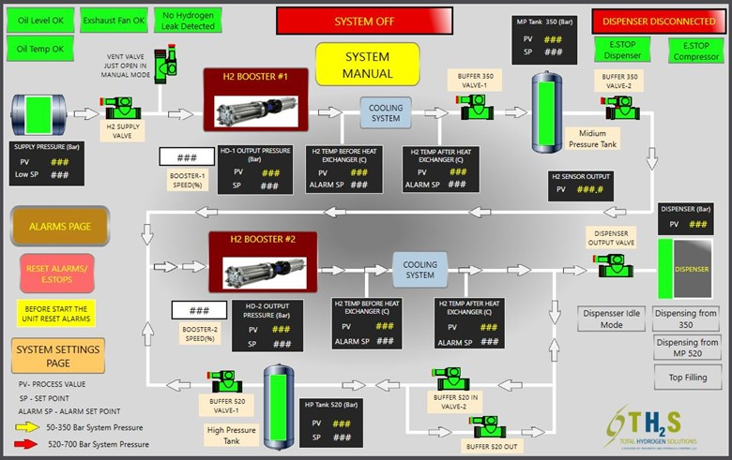 **Image 3**

**Startup dispenser for first filling:**

* + Making sure Refueler is grounded.
  + Verify all pre startup procedures are completed.
  + Connect the hydrogen supply trailer to the inlet connection on the Refueler per procedure. Ensure all Valves on the compressor are in the following positions listed below:

The DCIV Valves will be automatically operated from the HMI (Human Machine Interface) on the H2B700 dispenser. While the MIV and MVV will be operated from inside the compressor skid section.

|  |  |  |  |
| --- | --- | --- | --- |
| **Compressor Skid** | | | |
| **Valve** | **Position** | **Valve** | **Position** |
| MIV1 | CLOSED | MVV3 | CLOSED |
| MIV2 | CLOSED | MVV4 | CLOSED |
| MIV3 | OPEN | CWIV1 | OPEN |
| MIV4 | OPEN | CWIV2 | OPEN |
| MIV5 | OPEN | CWIV3 | OPEN |
| MIV6 | OPEN | CWIV4 | OPEN |
| BIV1 | OPEN | CWIV5 | OPEN |
| BIV2 | OPEN | CWIV6 | OPEN |
| TIV1 | OPEN | CWIV7 | OPEN |
| TIV2 | OPEN | CWIV8 | OPEN |
| TIV3 | OPEN | CWIV9 | OPEN |
| TIV4 | OPEN | CWIV10 | OPEN |
| TIV5 | OPEN | CWIV11 | OPEN |
| TIV6 | OPEN | CWIV12 | OPEN |
| TIV7 | OPEN | HIV1 | OPEN |
| TIV8 | OPEN | HIV2 | OPEN |
| TIV9 | OPEN | HIV3 | OPEN |
| MVV1 | CLOSED | HIV4 | OPEN |
| MVV2 | CLOSED | HIV5 | OPEN |
| DCIV1 | CLOSED | DCIV5 | CLOSED |
| DCIV2 | CLOSED | DCIV6 | CLOSED |
| DCIV3 | CLOSED | DCIV7 | CLOSED |
| DCIV4 | CLOSED | DCIV8 | CLOSED |

**Startup dispenser for first filling continued:**

* Ensure all Valves are in the following positions listed below:

|  |  |
| --- | --- |
| **Dispenser** | |
| **Valve** | **Position** |
| MIV-600-1 | OPEN |
| MIV-600-2 | OPEN |
| MIV-600-3 | OPEN |
| MIV-600-4 | OPEN |
| MVV-600-1 | CLOSED |
| MVV-600-2 | CLOSED |
| MVV-600-3 | CLOSED |
| MVV-600-4 | CLOSED |
| MVV-600-5 | CLOSED |
| MVV-600-6 | CLOSED |
| MVV-600-7 | CLOSED |
| DCIV-600-1 | CLOSED |
| DCIV-600-2 | CLOSED |
| DCIV-600-3 | CLOSED |
| DCIV-600-4 | CLOSED |
| DCIV-600-7 | CLOSED |
| DCIV-600-8 | CLOSED |
| DCVV-600-1 | CLOSED |

Note: the MIV’s should be open for flow, while the MVV’s are closed to allow proper flow of H2 in the system.

Note 2: The DCIV and DCVV will be automatically opened or closed based on the HMI settings selected.

* Go to the main power distribution panel and move all breakers to the closed/on position.
* Turn on the T40 KUSTEC Chiller & 20 Ton COLDSHOT Chiller by turning on the HPU.
* On the H2B700 Control panel place the System on/off switch into the on position

HMI Dispenser Operation Process for Hydrogen Mobile Refueler:

1. **Ensure E-Stop is Released:**
   1. Verify that the **e-stop button** (red button) is **pulled out** to deactivate it.
   2. Press the **reset button** and wait for the HMI screen to show the main operating menu. This confirms that the **e-stop has been successfully released**.
2. **After E-Stop is Released:**
   1. The HMI screen will display the main menu.
   2. Connect the H70, H35, nozzles to the vehicle.
   3. Press the "Start" button on the HMI screen to initialize the system.
3. **Select Vehicle Type:**

The HMI will display a graphical interface with vehicle type options.

Choose the appropriate refueling option:

|  |  |  |
| --- | --- | --- |
| A | B | C |
| H35 (350 bar) Vehicle | H70 (700 bar) Vehicle | Tube Trailer |

Note: During fueling there is an emergency stop on the dispenser, and HPU in case of emergency.

**Shutdown Process**

Note: Once the fueling and done and a new location is required proceed with the following to shut down the system.

1. **Gradual Pressure Reduction:**
   * Slowly reduce the system pressure by lowering the set pressure on the HPU and venting any excess pressure via the pressure relief valve, if necessary.
2. **Turn Off the HPU:**
   * Turn off the HPU motor after ensuring pressure has been safely reduced.
   * Bleed off any residual hydraulic pressure from the lines, using the MVV’s in the open position.
3. **Turn Off the Chiller:**
   * Shut down the chiller system.
   * Ensure that coolant flow has ceased, and that the chiller cools down safely**.**
4. **Close Hydrogen Lines:**
   * Close hydrogen inlet and outlet lines.
   * Vent any remaining hydrogen safely from the system.
5. **Drain and Check Fluid Levels:**
   * If necessary, drain excess fluids such as hydraulic oil or glycol-water mixture. Semiannually after date of 1st operation.
   * Inspect and top off fluids before storage or the next use.
6. **Power Down Electrical Panels:**
   * Turn off all power sources.
   * Ensure all electrical components are powered down and locked out, if required.
7. **General Inspection:**
   * Inspect the system for any residual leaks or issues entailing (drips, hissing sounds, etc.).
   * Perform post-operation maintenance tasks such as cleaning filters, inspecting valves, and checking fluid contamination levels.

# Emergency shutdown procedure

1. **Push the ESD button:**
   * Engage the ESD button, it should **click or lock** into place once activated.
2. **Verify System Shutdown:**
   * Immediately verify that the system is shutting down.
   * This includes powering down all motors, including the HPU, compressor motor, and chiller.
   * If they are not off, go back to the ESD button and confirm it is fully engaged. Note all HMI screens should be black if off.
3. **Perform a Safety Check:**
   * Once deemed safe, conduct a quick **visual check** of the equipment and surrounding area to confirm that there are no immediate hazards, leaks, or damage.

Preventive Maintenance

* All maintenance, including lubrication and adjustments, shall be performed only by qualified and trained personnel designated by the operating company.
* It is important that a maintenance program be established to ensure that all components are maintained in a condition which does not constitute a hazard to personnel. Do a full system check ranging from the HPU, Compressor Skid, Bottle Rack, and Dispenser and all their connections and outlets are properly mounted, or free of any obstructions once a month.
* When a unit is stopped for maintenance purposes, starting devices or powered accessories shall be locked or tagged out in accordance with a formalized procedure designed to protect all persons or groups involved with the machine against an unexpected start.
* Replace all safety devices and guards before starting equipment for normal operation.

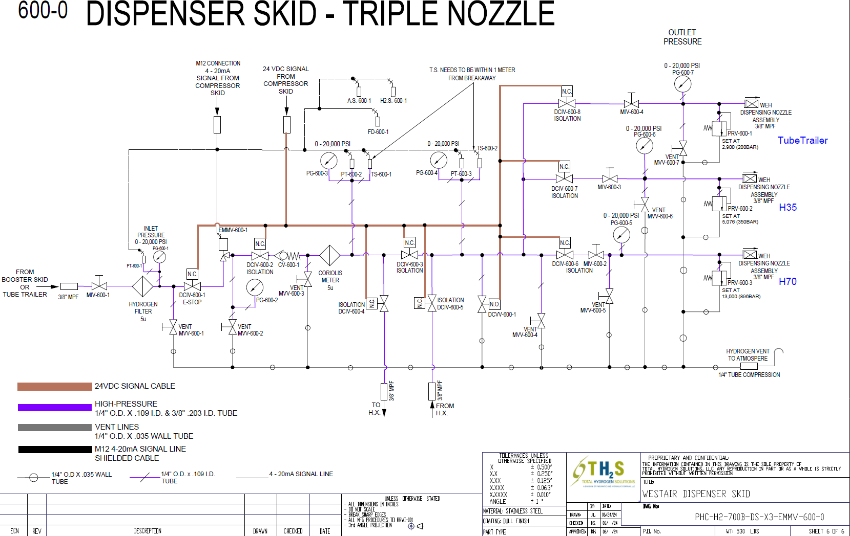Pneumatic & Hydraulic Schematic

# A diagram of a computerElectrical Schematic

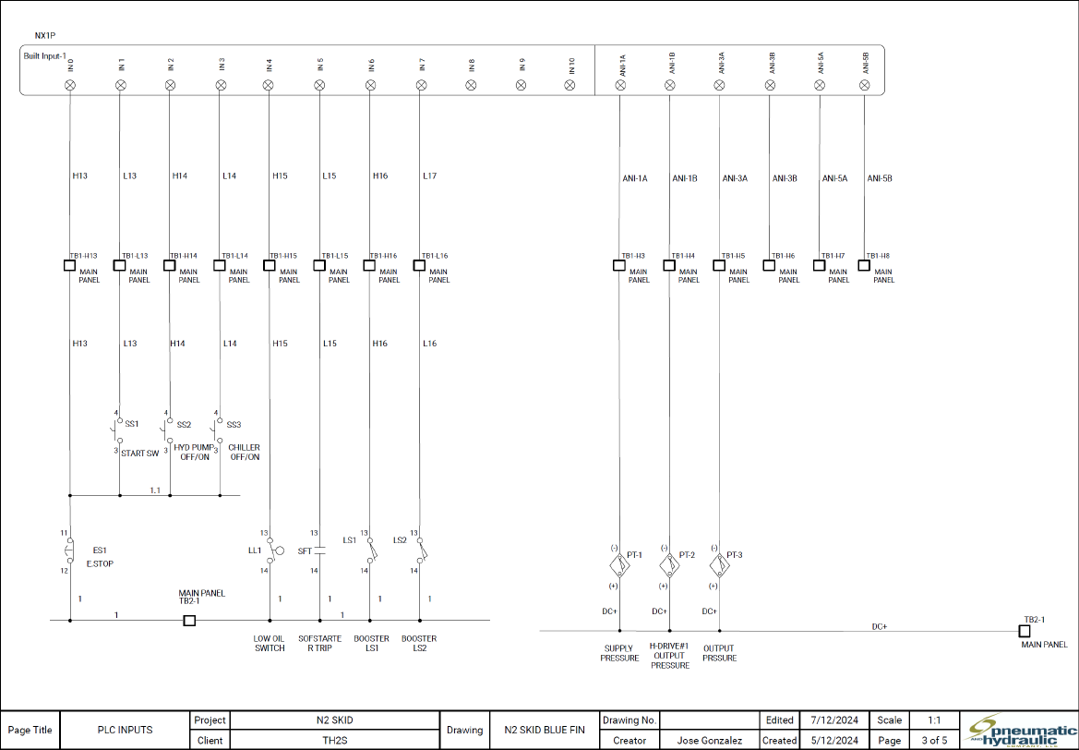

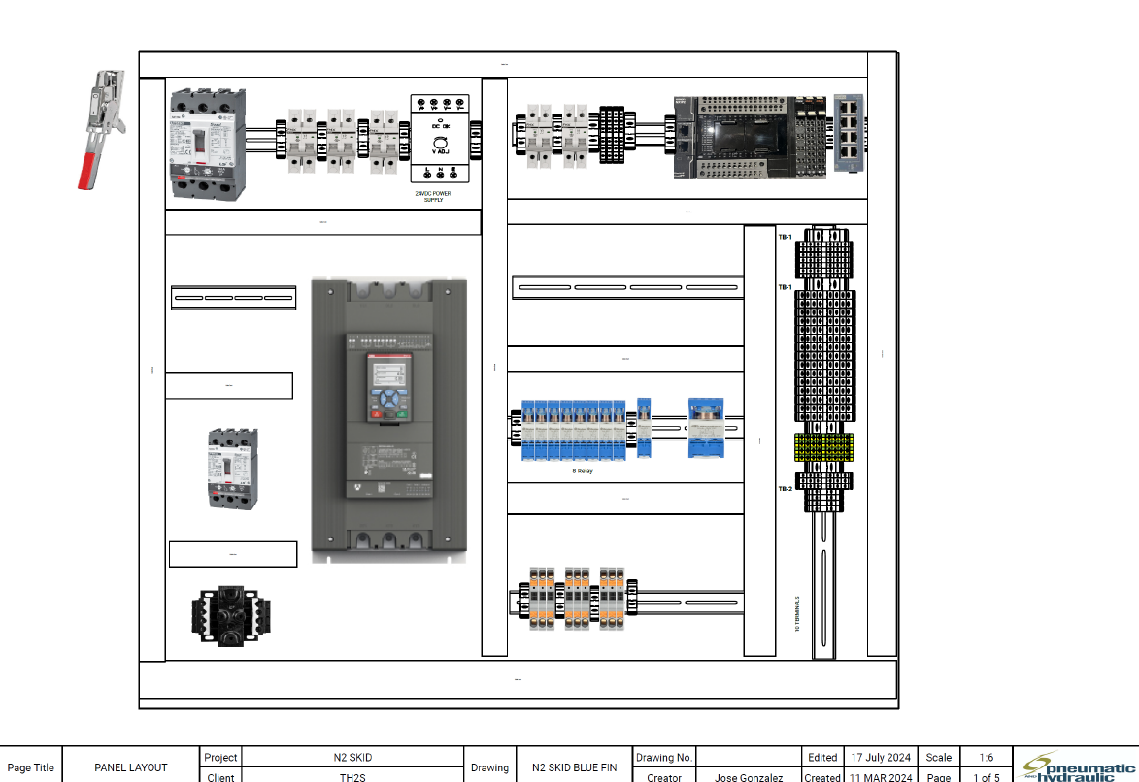

Appendix, A: Spare Parts List

|  |  |
| --- | --- |
| **Dispenser Recommendation Spare Parts List** | |
| **Part Numbers** | **Description** |
| RCM-B00AF-3-20UV61V | R-SERIES 10...24VCD ACTUATOR * BUTECH 20K VALVE |
| WT-FTH-080-L06-5 | FILTER, PARTICAL |
| 800.819.00 | 1000 BAR DN6 A-3/8 (3106) + 24V COIL |
| 800.817.00 | 1000 BAR DN0.5 A-1/4 (3105) + 24V COIL |
| HPC020ME39D2B2EZZZZMC | CORIOLIS METER, H.P. MICRO MOTION, 1/6 INCH (DN3) XM-19 S.S. 839 BAR |
| 4700R13AB2AAZZZAZZ | FIELD MOUNT TRANSMITTER, 4700 MICRO MOTIONS |
| 20SM6081-FRC1X-HYG | FLOW CONTROL |
| 20UV62V-PM-H2-S | NEEDLE VALVE, 3/8" MPF, 20,000 PSI |
| 20UV42V-PM-H2-S | NEEDLE VALVE, 1/4" MPF, 20,000 PSI |
| HIP-10RV-HYD | RELIEF VALVE, ADJUSTABLE,316A, HYDROGEN SERVICE, 1K - 10K SET RANGE |
| HIP-20RV-HYD | RELIEF VALVE, ADJUSTABLE,316A, HYDROGEN SERVICE, 10K - 20K SET RANGE |
| TST43B-1HX3/101 | AMBIENT SENSOR, 4-20MA |
| 6809685 | DRÄGERSENSOR, HYDROGEN H2 |
| **Compressor Skid Spare Part List** | |
| 52180-1 | PILOT SWITCH, N.C., 150 - 300 |
| 55792 | PILOT SWITCH, N.O., 4,500 - 20,000 |
| 15700-25 | RELIEF VALVE |
| SLPV82V-ATC5 | ACTUATOR VALVE, 1/2" LPF, ANGLE, 5,500 PSI, AIR TO CLOSE |
| SLPV82V-ATO5 | ACTUATOR VALVE, 1/2" LPF, ANGLE, 5,500 PSI, AIR TO OPEN |
| SLPV82V-PM | NEEDLE VALVE, 1/2" LPF, ANGLE, 5,500 PSI |
| SLPV42V-PM | NEEDLE VALVE, 1/4" LPF, ANGLE, 11,500 PSI |
| 20UV62V-ATO5 | ACTUATOR VALVE, 3/8" MPF, ANGLE, 20,000 PSI, AIR TO OPEN |
| 20UV42V-ATC5 | ACTUATOR VALVE, 1/4" MPF, ANGLE, 20,000 PSI |
| 20UV42V-PM | VALVE |
| 20LF6-40/20 | LINE FILTER |
| 41SV-20K-FP-B-1/4HPF-CALIB | GAUGE, 4" DIA., 0-20,000 PSI, P/M, BAR, 1/4" HPF, W/ CALIBRATION |
| 40SV-1K-FP-B-1/4MPF-CALIB | GAUGE, 4" DIA., 0-1,000 PSI, P/M, BAR, 1/4" MPF, W/ CALIBRATION |
| 20S-200-FP-B-GF | GAUGE, 2.5" DIA., 0-200 PSI, P/M, BAR, GLYCERIN FILLED |
| ESI-GS4200B-0014-AM-0.1 | TRANSDUCER,14BAR/200PSI, 4-20mA, M12, ACCURACY NLHR 0.1% |
| ESI-GS4200B-0069AM-0.1 | TRANSDUCER, 69BAR/1,000PSI, 4-20mA, M12, ACCURACY NLHR 0.1% |
| ESI-GS4200B-1379AM-0.1 | TRANSDUCER, 1379BAR/20,000PSI, 4-20mA, M12, ACCURACY NLHR 0.1% |
| R55M-2HG | AIR REGULATOR, 1/4" FNPT |
| 8210G002-24VDC | SOLENOID VALVE, 2-WAY, 1/2" FNPT, AIR/WATER, NC, 24VDC |
| P32PA94AD2VM1A | ELECTRO/PNEUMATIC AIR REGULATOR, 1/2" FNPT |
| P31PA92AD2VM1A | ELECTRO/PNEUMATIC AIR REGULATOR, 1/2" FNPT |
| CB-M12-4P-4M | ELECTRICAL CABLE FOR REGULATOR |
| S2FSSRRSLTT025 | BALL VALVE, 1/4" FNPT, P/M |
| S2FSSRRSLTT050 | BALL VALVE, 1/2" FNPT, P/M |
| KW204-BN-16-16 | BALL VALVE, 1/4" MPF |
| K63-14-14 | BALL VALVE, 3/8" LPF |
| **Storage Skid Spare Part List** | |
| 20UV62V-PM-H2-S | NEEDLE VALVE, 3/8" MPF, 20,000 PSI |
| 20UV42V-PM-H2-S | NEEDLE VALVE, 3/8" MPF, 20,000 PSI |
| 20A6M4M | ADAPTER, 3/8" MPM X 1/4" MPF, 20K |
| 20BF6 | BULKHEAD, 3/8" MPF, 20,000 PSI |

# Appendix, B: Additional Manuals: KUSTEC cooling system "Racoon”

# Main components KUSTEC COOLING SYSTEM "RACOON”

# Maintenance & Maintenance Calendar: KUSTEC cooling system "Racoon”

# COLDSHOT 20T PORTABLE AIR-COOLED CHILLER (model ACWC-240-E) Manual:

# Coldshot 20T Chillier Maintenance:

# Trouble shooting 20T Coldshot Chiller:

# Appendix, C: Coldshot Chiller Start Up Checklist

